Readify - Intelligent Assistant to Improve Reading and Comprehension Skills in English Language

Kumarathunga S. A. D. S.  
*Department of Computer Systems*

*Engineering*

*Sri Lanka Institute of Information*

*Technology*

*Malabe, Sri Lanka*  
[it21118340@my.sliit.lk](mailto:it21118340@my.sliit.lk)

Senanayake W.G.B.  
*Department of Computer Systems*

*Engineering*

*Sri Lanka Institute of Information*

*Technology*

*Malabe, Sri Lanka*  
it21158322@my.sliit.lk

Ranaweera A.P.  
*Department of Computer Systems*

*Engineering*

*Sri Lanka Institute of Information*

*Technology*

*Malabe, Sri Lanka*  
 [it21182396@my.sliit.lk](mailto:%20it21182396@my.sliit.lk)

Jeewaka Perera  
*Department of Computer Systems*

*Engineering*

*Sri Lanka Institute of Information*

*Technology*

*Malabe, Sri Lanka*  
jeewaka.p@sliit.lk

Sooriyaarachchi M.D.A.  
*Department of Computer Systems*

*Engineering*

*Sri Lanka Institute of Information*

*Technology*

*Malabe, Sri Lanka*  
 [it21173790@my.sliit.lk](mailto:%20it21173790@my.sliit.lk)

Dasuni Nawinna  
*Department of Computer Systems*

*Engineering*

*Sri Lanka Institute of Information*

*Technology*

*Malabe, Sri Lanka*  
dasuni.n@sliit.lk

*Abstract*— In an era dominated by information, advanced English reading comprehension is crucial, yet many learners struggle to develop these skills. This research addresses the gap by introducing Readify, an intelligent web application designed to enhance reading comprehension for English language learners. This study aimed to develop a system that provides dynamically adaptable content and automated, descriptive evaluations, focusing on critical comprehension areas like narrative sequencing, text summarization, and self-questioning. Readify was developed as a web application with a user-friendly interface and a robust back-end, integrated with a Retrieval-Augmented Generation (RAG) based AI agent. This agent dynamically generates interactive lessons and quizzes tailored to user interests and learning progress. Furthermore, it employs advanced prompt engineering techniques to deliver nuanced, human-like evaluations and feedback for essay-type answers. Readify demonstrates the potential of AI to revolutionize English language education by offering a personalized and adaptable learning environment, automating content creation and assessment. Future work should focus on empirical evaluations to quantify its impact on learners' reading comprehension skills and guide further development.

Keywords—Reading Comprehension, Large Language Model, Retrieval Augmented Generation, Descriptive Answer Evaluation, Question Generation, English Language

# Introduction

In today's information-rich world, mastering the English language requires more than just basic vocabulary and grammar; advanced reading comprehension skills are most important. These skills, including the ability to understand implied meanings, critically evaluate content, and derive conclusions, are vital for effective communication and learning[1]. Key components include connecting different parts of a text, leveraging prior knowledge, identifying central themes, finding important facts and supporting details, summarizing information, and asking relevant questions. The significance of strong reading comprehension in English language acquisition is particularly pronounced in an age where vast amounts of information are readily accessible yet require careful analysis and interpretation. English, as a global language, acts as a gateway to this extensive information landscape, making reading comprehension proficiency essential for accessing, processing, and applying knowledge effectively.

Despite the acknowledged importance, many English language learners encounter significant challenges in developing advanced comprehension skills. These challenges often stem from factors such as limited vocabulary, disengagement with learning materials, and insufficient opportunities to practice higher-order thinking[2]. This persistent challenge has created a considerable interest in harnessing the capabilities of Artificial Intelligence (AI) to revolutionize English language education, particularly in enhancing reading comprehension. AI-driven platforms offer the promise of personalized learning experiences, adapting to individual learner needs and providing immediate, insightful feedback. By analyzing learner interactions and identifying areas of weakness, these platforms can deliver targeted exercises designed to improve comprehension abilities. Although the effectiveness of AI in various educational settings is extensively supported by research, its targeted application to enhance reading comprehension in English, particularly for non-native speakers, continues to be an underexplored domain of research.

Addressing this gap, this research introduces Readify, an intelligent assistant designed to enhance advanced reading comprehension skills in English language learners. The primary research problem lies in the current lack of dynamically adaptable content for reading comprehension and the limited availability of tools capable of providing automated, descriptive evaluations for essay-type questions, traditionally requiring human assessment. Therefore, the main objective of this study is to develop a web application that empowers English language learners to improve advanced comprehension skills, specifically focusing on critical areas such as sequencing narratives, summarizing texts, and employing self-questioning techniques to deepen understanding. To achieve this, Readify incorporates two specific research objectives: (1) utilizing a Large Language Model (LLM) to generate dynamic and engaging content, including lessons and exercises tailored to individual user interests, and (2) leveraging the same LLM to accurately evaluate user-generated answers and provide meaningful feedback without human intervention.

Readify is structured around three core functionalities. Firstly, the Interactive Lesson Generation module employs prompt engineering and Retrieval-Augmented Generation (RAG) techniques to dynamically create lesson content that aligns with the user's specified interests, ensuring relevance and engagement. Secondly, the Dynamic Quiz Generation module utilizes similar AI methodologies to produce quizzes that adapt to the user's progress and preferred topics, offering a continuously challenging and personalized assessment experience. Finally, the Answer Evaluation module is crucial for automated assessment, employing advanced algorithms to evaluate user responses against predefined criteria and provide comprehensive feedback on strengths and areas for improvement, thus automating the grading process and facilitating self-reflection. This introduction sets the stage for the subsequent sections of this paper, which will detail the methodology employed in developing Readify, present the results of its evaluation, discuss the findings in depth, and conclude with the implications and future directions of this research.

# Literature Review

The integration of artificial intelligence in education, particularly for enhancing reading and comprehension skills in English, has witnessed significant advancements. This literature review surveys contemporary research on AI-driven platforms that generate adaptive content and automatically assess essay-type responses, thereby contextualizing both recent advancements and the ongoing challenges in the field.

## Dynamically Adaptable Content

Several studies have explored AI’s potential in personalizing educational experiences. Mirabal et al. (2023)[3] demonstrated that deep learning-based language models could enhance reading comprehension by providing personalized content recommendations. Their work, however, is limited by its reliance on predefined pathways, which restricts its ability to adapt dynamically to the evolving needs of individual learners. Similarly, Laban et al. (2022)[4] investigated automated question generation for quiz design, offering tools that help teachers create customized assessments. Despite this, their approach remains largely teacher-driven and does not fully exploit AI’s capacity to modify instructional content in real time during a reading session.

To address these limitations, the proposed research seeks to develop an AI-enabled platform capable of providing real-time, dynamically adaptable content. By integrating advanced natural language processing (NLP) techniques with adaptive learning algorithms, the platform aims to continuously assess a learner’s comprehension and adjust reading materials accordingly. This strategy is designed to cater to the diverse and fluctuating comprehension levels of students, moving beyond the static delivery models prevalent in current literature.

## Automated Assessment for Essay-Type Questions

The challenge of automating the assessment of essay-type questions has also been a focus of research. Moholkar et al. (2024)[5] provided an extensive survey of machine learning techniques for evaluating descriptive answers. Their review highlights that while these models can perform basic grading tasks, they struggle with the intricacies of human language—such as context, tone, and rhetorical devices—which are essential for accurate and fair evaluation. In a similar vein, Xia et al. (2024)[6] examined large language models as tools for automated essay scoring using the TOEFL Independent Writing Task. Their findings indicate that although these models show promise, they are prone to being influenced by superficial features like essay length and vocabulary sophistication, and they often lack transparency in their decision-making processes.

Further, Hussein et al. (2019)[7] reviewed a range of automated essay scoring systems, noting that despite progress from rule-based to machine learning approaches, consistently replicating human-like grading—especially for creative or argumentative essays—remains an elusive goal.

The proposed research, Readify, aims to bridge these gaps by integrating adaptive content generation with a nuanced, linguistically informed assessment tool. This integrated approach is expected to provide a more personalized and effective learning experience by addressing current shortcomings in educational technology..

# Methodology

The foundation of Readify is a robust web application, comprising both a front-end and a back-end. The front-end is designed with a user-centric approach to ensure an intuitive and accessible interface. The back-end leverages FastAPI to manage server functionalities efficiently, offering scalability and low latency for real-time interactions. Firebase is employed for authentication and media storage, providing secure user access and reliable handling of content. This modular architecture ensures that Readify is both responsive and secure, meeting the demands of diverse educational environments.

## System Overview

The system is comprised of a web application and an AI agent. The web application is divided into a front-end and back-end, ensuring a smooth user interface coupled with robust functionalities. The back end is implemented using FastAPI, which efficiently manages server-side operations, while Firebase is utilized for authentication and media storage. This combination provides a secure, scalable, and responsive platform that can handle the diverse needs of its users

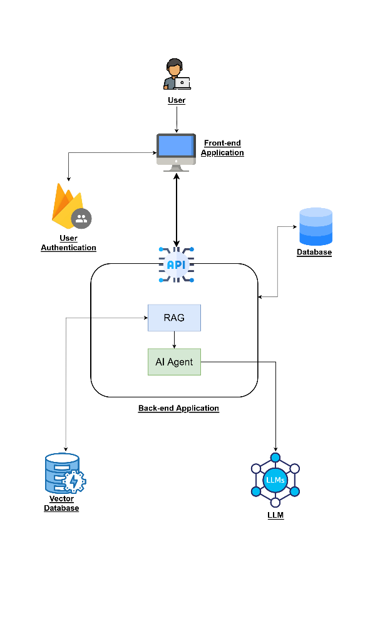

1. System Overview

In parallel, a RAG-based AI agent is developed to enhance the system's adaptability and responsiveness. As illustrated in Fig. 2, This agent is model agnostic and built using a suite of state-of-the-art tools and frameworks including LangGraph, LangChain, Chroma DB, and tool calling mechanisms. The integration of the ReAct framework further augments the agent's ability to dynamically retrieve and generate contextually relevant content. By fusing external knowledge sources with real-time processing, the AI agent can support tasks ranging from content generation to detailed assessment.

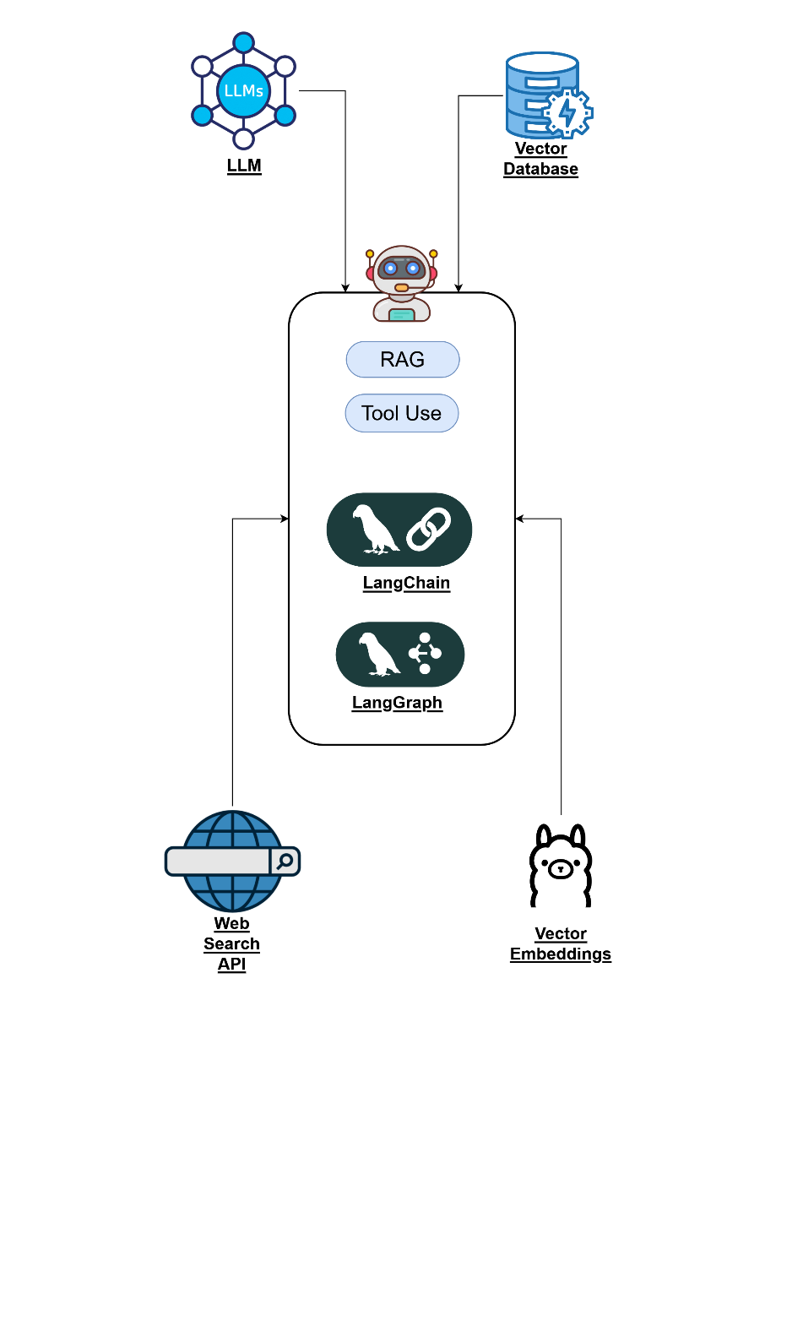

1. RAG-based AI Agent

## Paragraph and Question Generation

The generation of coherent paragraphs and relevant questions is a critical component of Readify, achieved through advanced prompt engineering techniques integrated within the RAG workflow. The system employs role-based prompting, wherein the AI model is assigned the persona of an expert educator to frame its responses, ensuring that the content is both pedagogically sound and tailored to enhance comprehension skills. In addition, zero-shot prompting leverages the model's inherent language capabilities, enabling it to generate responses without the need for extensive example-based training, thus fostering flexibility and rapid adaptation to various contexts. Guided prompting further refines this process by providing specific instructions that narrow the focus of the generated content, ensuring alignment with defined learning objectives and curriculum requirements.

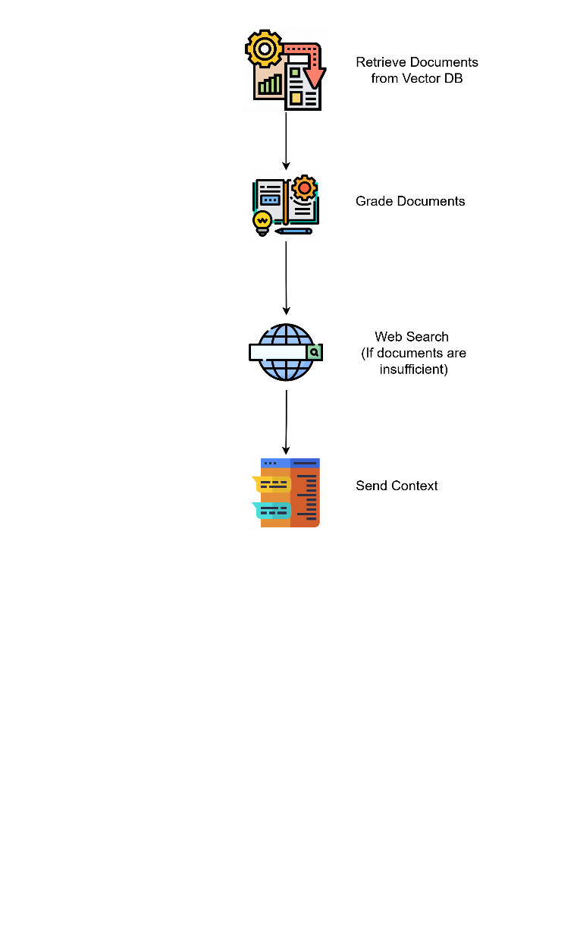

1. Retrieval-Augmented Generation Workflow

Fig.3 illustrates the RAG workflow which is pivotal in merging external knowledge retrieval with prompt-engineered generation. Initially, the system queries a structured knowledge base to retrieve relevant data, using Chroma DB for efficient storage and retrieval. The retrieved data is then fed into the LangChain framework, which orchestrates the synthesis of new content based on both the prompt inputs and the contextual information. Tool calling functions are integrated into the workflow to invoke specialized operations as needed. This multi-step process ensures that the generated paragraphs and questions are not only contextually rich but also dynamically tailored to individual learner profiles.

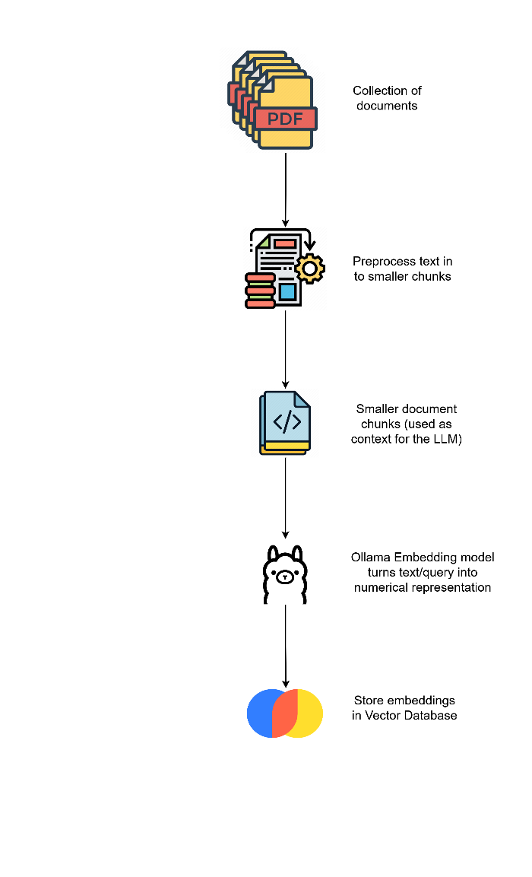

1. Document processing and Embedding creation

## Assessment and Feedback

Readify employs assessment and feedback mechanisms that emulate the detailed evaluations of human educators, leveraging advanced prompt engineering techniques. Specifically, the system utilizes role-based prompting, where the AI evaluates responses from the perspective of an experienced assessor, ensuring constructive and pedagogically sound feedback. To offer transparent and detailed evaluations, especially for essay-type answers, Readify incorporates chain-of-thought prompting. This method encourages the AI to articulate its reasoning in a step-by-step manner, providing clarity on the evaluation process. Furthermore, progressive prompting is employed to generate feedback iteratively, allowing the AI to refine its assessments as it gathers more context during the evaluation.

Through these integrated techniques, Readify's AI agent delivers nuanced assessments and actionable feedback, creating a dual capability of adaptive content generation and sophisticated evaluation that is central to providing a more personalized and effective learning experience.

# Discussion

The Readify intelligent assistant emerges as a comprehensive web application designed to address the critical need for enhanced reading comprehension skills in English language learners. This research introduces a system strategically built upon four key components: an intuitive web application, a RAG-based AI agent, dynamic content generation modules, and an advanced assessment and feedback mechanism. Each component is meticulously designed to contribute to a more effective and personalized learning experience.

Firstly, the robust web application, incorporating a user-friendly front-end and a scalable back-end powered by FastAPI and Firebase, provides a stable and accessible platform for learners. This foundation ensures that Readify can reliably deliver its functionalities across diverse educational settings. Secondly, the integration of a model-agnostic RAG-based AI agent, utilizing LangGraph, LangChain, and Chroma DB, is pivotal. This agent dynamically retrieves and processes information, enabling the system to generate contextually rich and relevant content. The agent's architecture, enhanced by the ReAct framework, allows for sophisticated operations ranging from creating personalized lessons to providing detailed evaluations, showcasing its adaptability and potential for continuous improvement.

The dynamic content generation modules, encompassing Interactive Lesson Generation and Dynamic Quiz Generation, are central to Readify's personalized approach. By employing advanced prompt engineering and RAG techniques, these modules create learning materials that are not only engaging but also directly aligned with individual user interests and learning progress. This tailored content aims to increase learner engagement and motivation, addressing a key challenge in English language acquisition. Furthermore, the Answer Evaluation module represents a significant advancement in automated assessment. By leveraging role-based, chain-of-thought, and progressive prompting, Readify emulates human-like evaluation, providing learners with nuanced and actionable feedback on essay-type answers. This feature automates a traditionally labor-intensive process, offering scalable and immediate feedback that can significantly enhance self-reflection and learning.

Collectively, these components demonstrate Readify's potential to revolutionize English language education by offering a dynamically adaptable and highly personalized learning environment. By automating content generation and assessment, Readify addresses the identified research problem of limited adaptable content and the scarcity of automated, descriptive evaluations. The system’s focus on critical comprehension skills such as sequencing narratives, summarizing texts, and self-questioning, further underscores its targeted approach to improving advanced reading abilities. While the technical architecture and AI methodologies are promising, future research should focus on empirical evaluations to quantify the impact of Readify on learners' reading comprehension skills and to identify areas for refinement and optimization. This initial framework, however, lays a strong foundation for leveraging AI to foster academic success in English language learning in the digital age.

# Conclusion

In conclusion, Readify, an intelligent assistant web application, has been developed to significantly enhance advanced reading comprehension skills for English language learners. This research successfully addressed the challenges of limited adaptable content and the scarcity of automated evaluation tools by introducing a system built upon four core components. Firstly, a user-friendly and robust web application provides a stable and accessible learning platform. Secondly, the integration of a RAG-based AI agent, utilizing advanced frameworks, enables dynamic retrieval and processing of information for personalized content generation and sophisticated evaluations. Thirdly, dynamic content generation modules for interactive lessons and quizzes ensure engaging and tailored learning experiences aligned with individual user interests and progress. Finally, the advanced assessment and feedback mechanism, employing sophisticated AI prompting techniques, delivers nuanced, human-like evaluations for essay-type answers, automating a traditionally labor-intensive process. Readify demonstrates the transformative potential of AI in English language education by offering a dynamically adaptable and personalized learning environment. Future research should prioritize empirical evaluations to quantify Readify's impact on learners' reading comprehension and to guide further refinements and optimizations, ensuring its effectiveness in fostering academic success in the digital age.

##### References

1. Marigold Academy, “Importance of Reading Comprehension and Writing Skills - Marigold Academy,” Marigold Academy, Apr. 30, 2024. https://marigoldacademy.com/blog/importance-of-reading-comprehension-and-writing-skills/
2. G. Brooks, J. Clenton, and S. Fraser, “Exploring Potential Factors Affecting Reading Comprehension in EAL Learners: A Preliminary Corpus-Based Analysis,” Languages, vol. 10, no. 2, p. 30, Feb. 2025, doi: https://doi.org/10.3390/languages10020030.
3. ‌ P. Mirabal, M. Castillo-Sanhueza, R. Curín-Zarate and O. O. Calzadilla-Pérez, "Use of Language Models based on Deep Learning to improve reading comprehension," 2023 42nd IEEE International Conference of the Chilean Computer Science Society (SCCC), Concepcion, Chile, 2023, pp. 1-6, doi: 10.1109/SCCC59417.2023.10315757.
4. P. Laban, C. Wu, L. Murakhovs'ka, W. Liu, & C. Xiong, "Quiz Design Task: Helping Teachers Create Quizzes with Automated Question Generation," in NAACL-HLT, 2022.
5. K. Moholkar, M. Chaturvedi, A. Jain, A. Parkhe and K. Singh, "Machine Learning Techniques for Descriptive Answer Evaluation: A Comprehensive Survey," 2024 International Conference on Inventive Computation Technologies (ICICT), Lalitpur, Nepal, 2024, pp. 1412-1419, doi: 10.1109/ICICT60155.2024.10544714.
6. W. Xia, S. Mao, & C. Zheng, "Empirical Study of Large Language Models as Automated Essay Scoring Tools in English Composition Taking TOEFL Independent Writing Task for Example," ArXiv, vol. abs/2401.03401, 2024.
7. M. A. Hussein, H. A. Hassan, & M. Nassef, "Automated language essay scoring systems: a literature review," PeerJ Computer Science, vol. 5, 2019.
8. K. Hilali, M. Chergui and A. Ammoumou, “Adaptive Learning Systems: A Comprehensive Overview and Identification of Challenges,” 2023 IEEE International Conference on Technology Management, Operations and Decisions (ICTMOD), Rabat, Morocco, 2023, pp.1-7, doi: 10.1109/ICTMOD59086.2023.10438128.